## MODIFY AGE REF NUMBER

|  |  |
| --- | --- |
| User Name: ……………………………………………. | Trainer Name: Ruchira Ariyasinghe |
| User Sign. : ……………………………………………. | Trainer Sign. : ……………………………………………. |

##### MODIFY AGE REF NUMBER

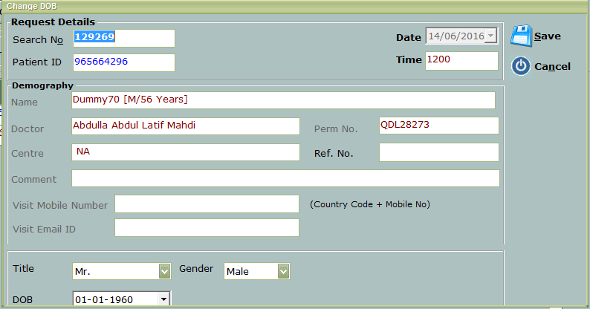

##### Enter the patient id in patient id

* User can change the patient DOB , title and Ref No from this option
* Click on save button to save the changes.